***Zipped Directory***





***Project Video***

[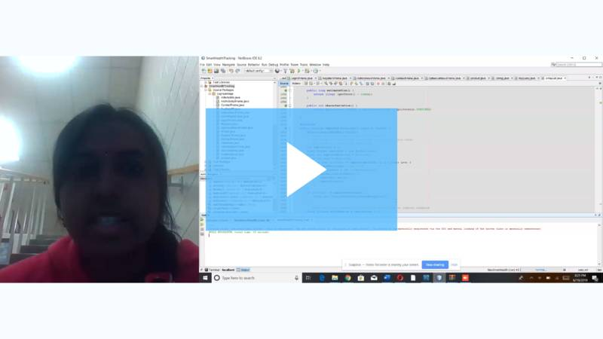](https://soapbox.wistia.com/videos/tlFLXBmCpx)

[Soapbox - Untitled Recording — Jun 19, 8:36 pm](https://soapbox.wistia.com/videos/tlFLXBmCpx)